Brain Tumour Image Segmentation Using Deep Networks

In this project as extension we have added RESNET algorithms which can extract segmented part from image with more clarity compare to existing UNET algorithms. Due to pixel clarity we can get high DICE score similarity between original and predicted image.

Run project as per previous steps and I added extra button to apply RESNET on input image and then show segmented UNET and RESNET image and between this two images you can see RESNET with more clarity

To run project double click on ‘run.bat’ file to get below screen

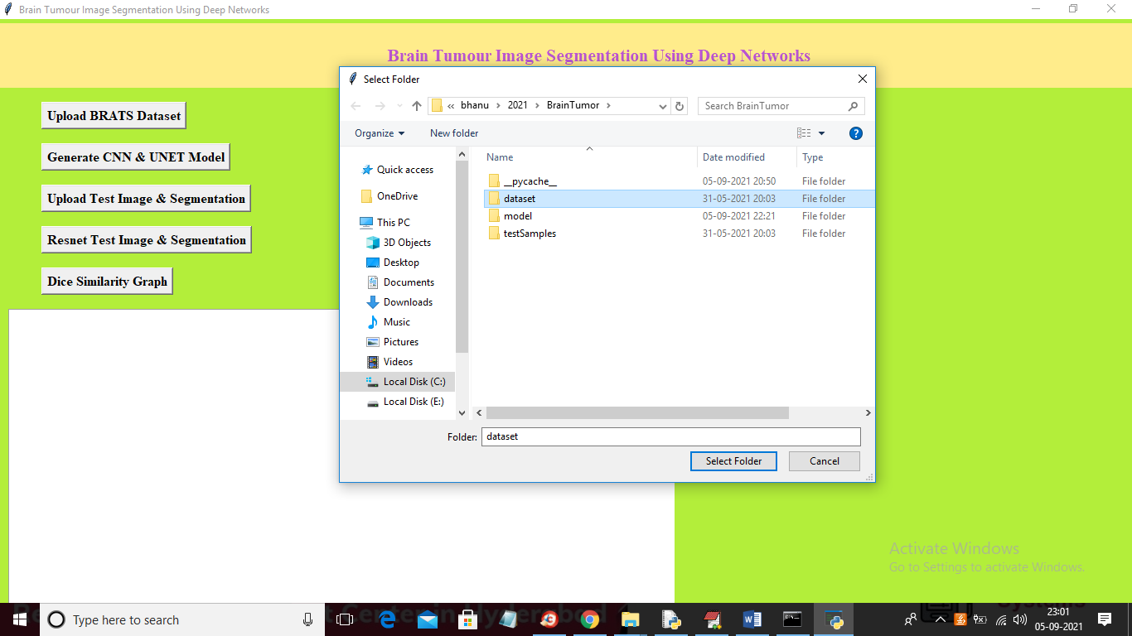

In above screen uploading dataset folder and then click on ‘Generate CNN & UNET Model’ button to load UNET model and to get bellow screen

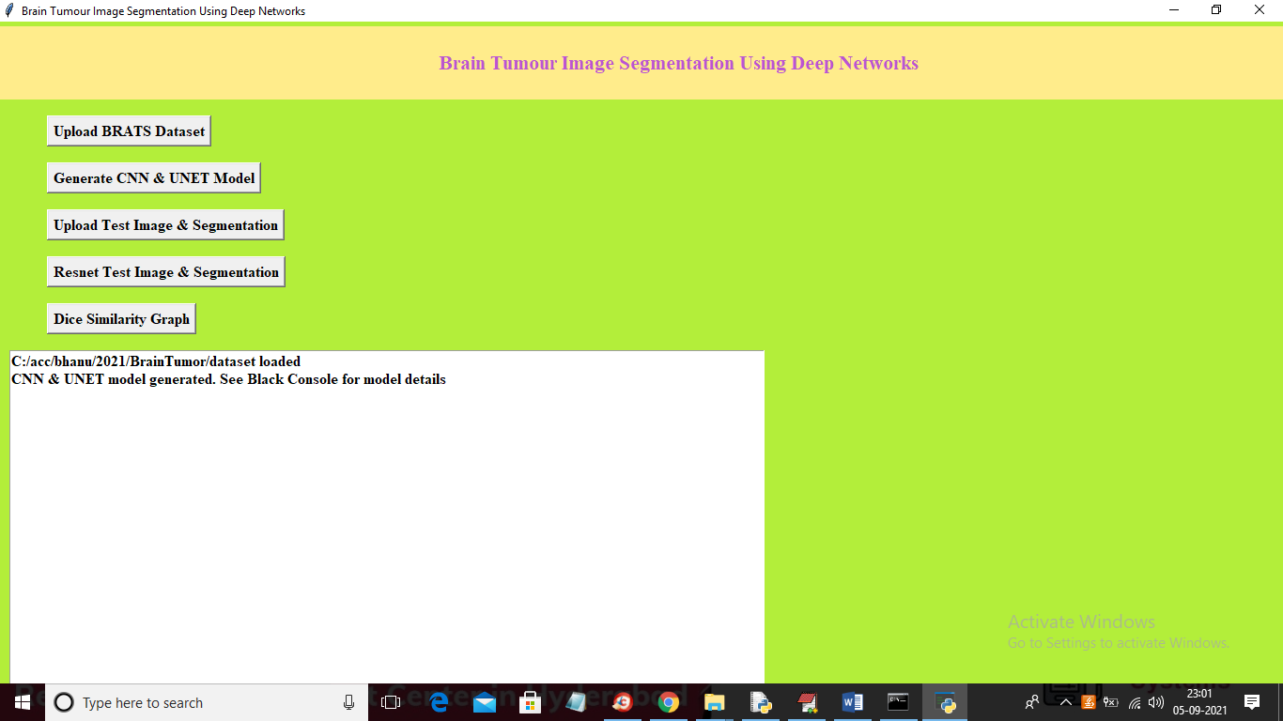

In above screen UNET model is loaded and now click on ‘Upload Test Image & Segmentation’ button to perform segmentation using UNET and to get below screen

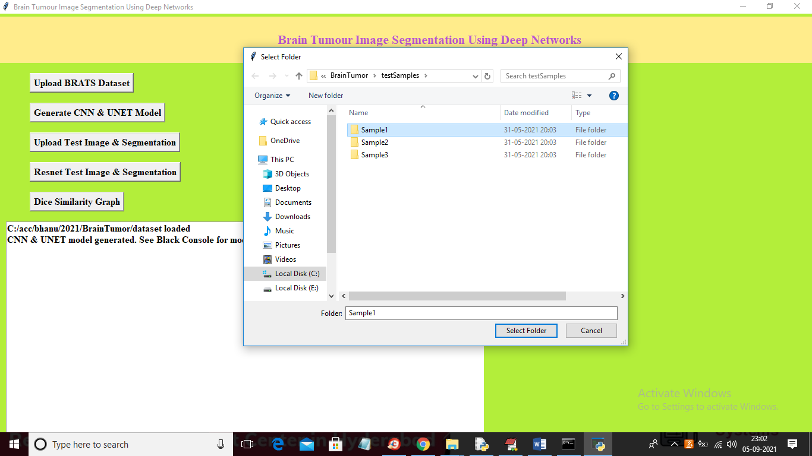

In above screen selecting and uploading ‘Sample1’ folder and then click on ‘Select Folder’ button to get below output

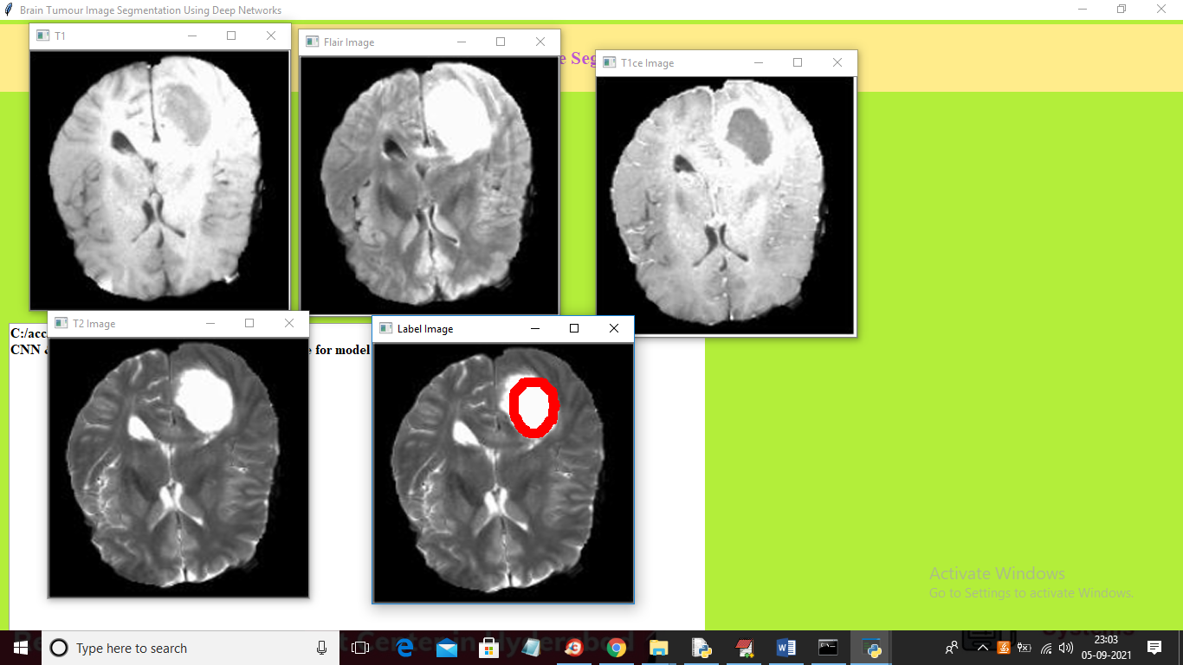

In above screen we can see UNET extracted segmented part and then put bounding box around it and now click on ‘Resnet Test Image & Segmentation’ button to get segmented image with RESNET and then we can see difference between UNET segmented and Resnet segmented image

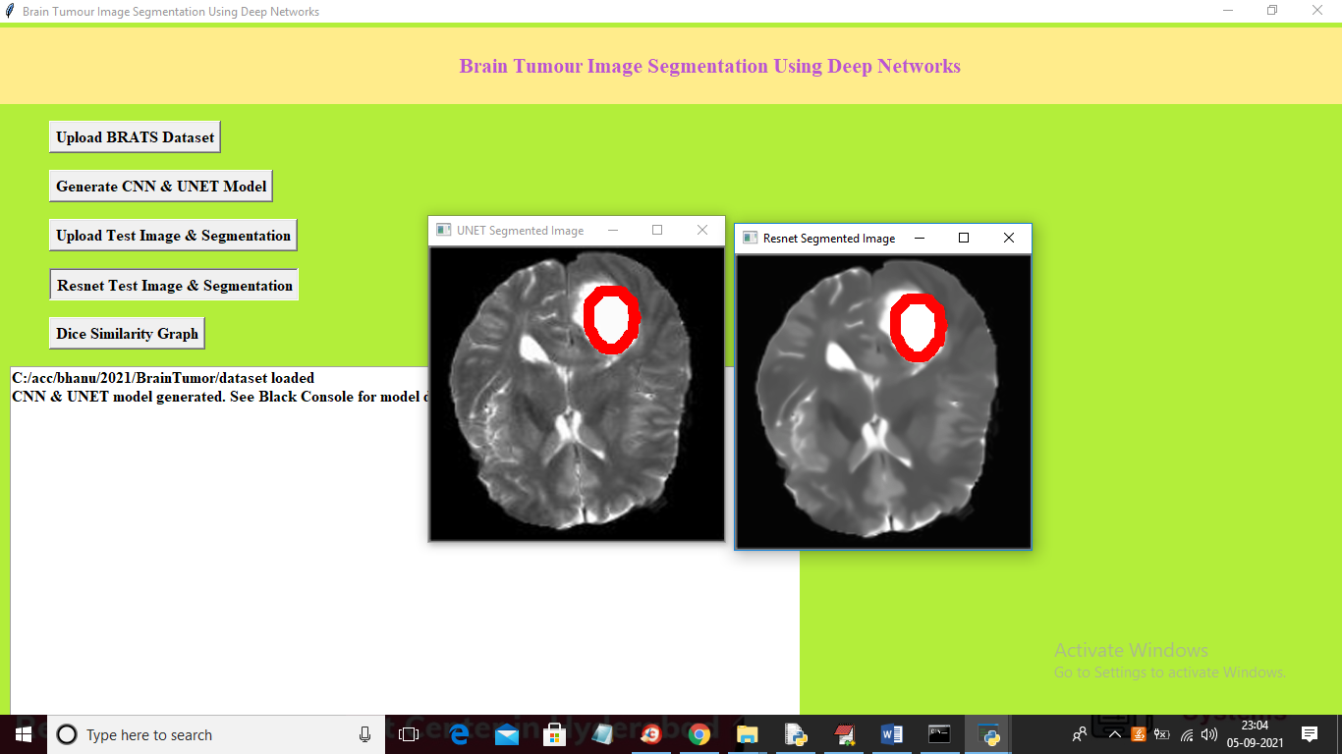

In above screen first image is the UNET segmented image and second one is the RESNET segmented image and in second image we can see little clarity in pixels as in first UNET image there are little black dots in pixels and this dots are removed in RESNET and similarly you can upload other images and test. Now click on ‘Dice Similarity Graph’ button to get below graph

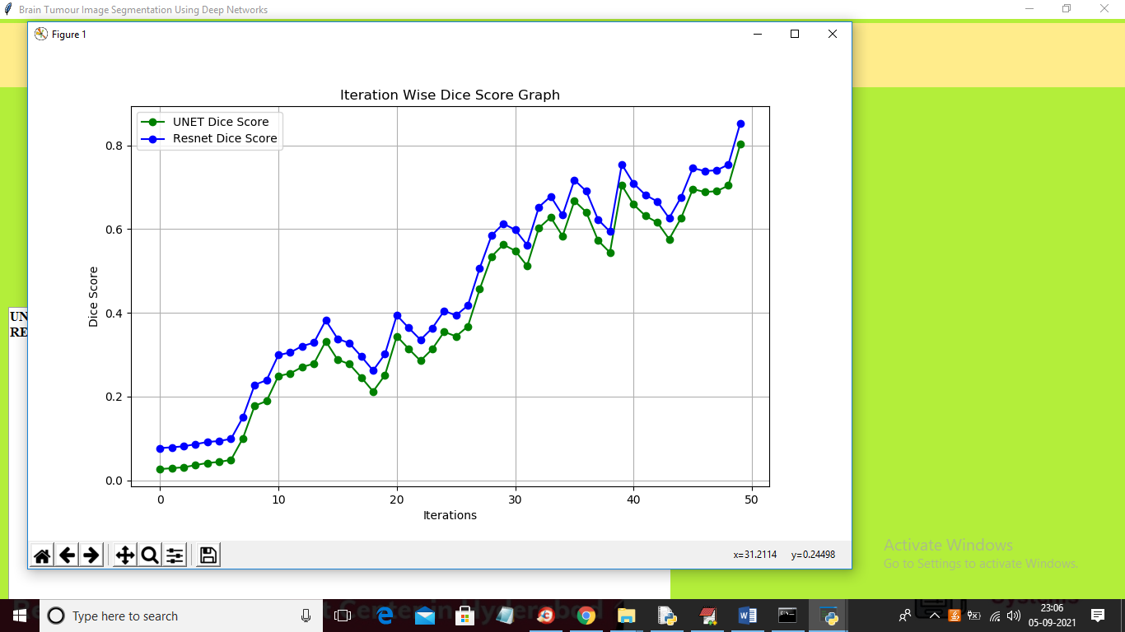

In above graph x-axis represents epoch/iterations used to train both models and at each increasing epoch we can see both models similarity between original and predicted images increased but Resnet got more similarity with predicted and original images so its score is high compare to UNET. In above graph green line represents UNET score and blue line represents RESNET score.